|  |
| --- |
| **Introduction to Internet and Web** |
| Assignment #01 Report |

|  |  |
| --- | --- |
| **Name** | 장현빈 |
| **Stu ID** | 202555444 |
| **Dept.** | 정보컴퓨터공학부 인공지능전공 |
| **Section** | 059 |

## <Note>

* Submit this document as well as the entire working directory for this assignment on PLATO.
* Missing code yields 20% of points deduction.
* Compress the entire working directory (including the HTML source code and media files) as a single zip file.
  + If you need a tool/software to create a zip file, please visit: https://kr.bandisoft.com/bandizip/
* You may need to take screenshots and attach in this report.
* For Window OS users, to take a screenshot:
  + Press Windows logo key + Shift + S, *OR*
  + Press Print Screen (PrtSc) key.
* For Mac OS users, to take a screenshot:
  1. To take a screenshot, press and hold these three keys together: Shift, Command, and 3.
  2. If you see a thumbnail in the corner of your screen, click it to edit the screenshot. Or wait for the screenshot to save to your desktop.
* Additional notes
  + If the deadline is 13:30, it means 13:30:00 (= 13-hour, 30-minute and 00-second)
  + Make sure to use relative pathnames so that your code works on the grader’s computer

## <Assignments>

|  |
| --- |
| **[Q 1] Short resume in HTML5 [points: 100]**  Let’s create a short resume webpage in HTML5. Overall, it should look as below. |

|  |
| --- |
| **[Q 1.1] Webpage title [points: 5]**  Set the webpage title as below |
|  |

Attach the screenshot of the corresponding area in the webpage:



|  |
| --- |
| **[Q 1.2] Uppermost section [points: 15]**  The uppermost section looks as below. Replace the text in <h1> with your student ID and your name. Also, there are five shortcuts that are used to directly jump to each corresponding sections using anchors and href tag.  For example:   * Adding anchors:   + <h2 id="shortintro">1. Short Intro</h2>   + Or, you can use <a id="shortintro">…</a> tag to create an anchor * Creating a shortcut to an anchor: <a href="#shortintro">1. Short Intro</a> |
|  |

Attach the screenshot of the corresponding area in the webpage:



|  |
| --- |
| **[Q 1.3] Section 1, short bio [points: 15]**  The section 1 looks as below. The section title is using <h2> tag. The contents are written with a table with zero-width border, and the image size is 60x60 pixels. At the bottom, there is a shortcut to the uppermost section using anchor, and this will repeatedly appear in each section. Texts should be shown in the following manner, including the line changes.  * Please use the relative file path when referencing the image file to display. |
|  |

Attach the screenshot of the corresponding area in the webpage:



|  |
| --- |
| **[Q 1.4] Section 2, education [points: 15]**  The section 2 looks as below. The section title is using <h2> tag. The contents are written with nested <dl> and <ul> (University name and department names are using <dl>, and the course list is using <ul>). |
|  |

Attach the screenshot of the corresponding area in the webpage:



|  |
| --- |
| **[Q 1.5] Section 3, programming skills and level [points: 15]**  The section 3 looks as below. The section title is using <h2> tag. The contents are written with a table with a border width of 1. You can find the images on PLATO or online.   * Note that images should be saved/located under the media directory  (i.e., your_current_woring_directory/media/image_files_should_be_here). * Also, don’t forget to use the relative filepath in your HTML code. |
|  |

Attach the screenshot of the corresponding area in the webpage:

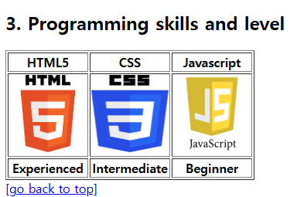

|  |
| --- |
| **[Q 1.6] Section 4, online resources [points: 15]**  The Section 4 looks as below. The section title is using <h2> tag. The contents are written with href tags. The links should work correctly (i.e., it should connect to the corresponding web site), and each should open a new window (by using _blank target) when clicked.   * Google: [www.google.com](http://www.google.com) * Naver: [www.naver.com](http://www.naver.com) * Github: [www.github.com](http://www.github.com) |
|  |

Attach the screenshot of the corresponding area in the webpage:

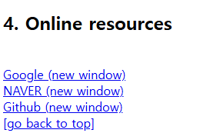

|  |
| --- |
| **[Q 1.7] Section 5, contact [points: 15]**  The section 5 looks as below. The section title is using <h2> tag, and the contents are written with <form> tag. Radio buttons allow only one option to be chosen, email field checks the format of the entered text (id@host), and the multi-line text area has the default message to be shown “(enter your message here)”. |
|  |

Attach the screenshot of the corresponding area in the webpage:

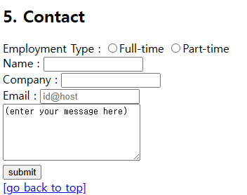

|  |
| --- |
| **[Q 1.8] Bottom section [points: 5]**  The bottom section looks as below. Please replace the name and dept with your name and your department name. |
|  |

Attach the screenshot of the corresponding area in the webpage:



Now, submit both the current document and the entire working directory on PLATO.

**THE END**